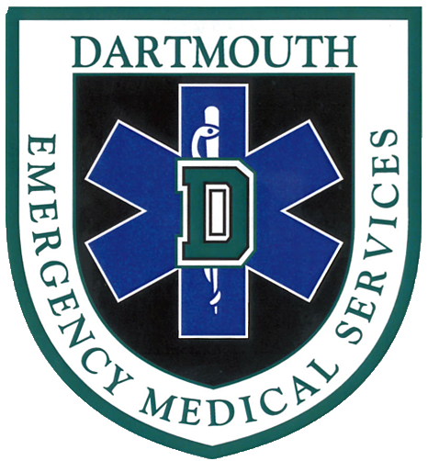
Dartmouth EMS
Spring 2017 Programming
(Scenario Sessions, Meetings, and Special Events)

1. Scenario Session: Mixed Bag Protocol Review
Tuesday, March 28th
6-8pm; Kemeny 008
Other EMTs on campus are encouraged to attend.

2. QAQI Call Review
Thursday, April 6th
5:30-7:00pm; Kemeny 007

3. Scenario Session: Youtube Trauma
Monday, April 10th
7-9pm; Kemeny 007
Other EMTs on campus are encouraged to attend.

4. Answering Patients’ Questions
Wednesday, April 19th
6-7:30pm; Silsby 028

5. Guest Lecture and Case Review: Pediatric Emergencies
Monday, April 24th
TBD; TBD
Open to anyone in the community.

6. MANDATORY Special Event: NNECEMS Conference
Saturday, April 29th
8am-5pm; TBD
Mandatory for Dartmouth EMS members.

7. Scenario Session: Trauma X and Behavioral Emergencies
Friday, May 5th
6:30-8:30pm; East Wheelock 4th Floor Andres

8. Scenario Session: Trauma (Bleeding Control and Vehicle Extrication)
Wednesday, May 10th
6-8pm; Fairchild 101
Other EMTs on campus are encouraged to attend.

9. MANDATORY Scenario Session: Green Key
Tuesday, May 16th
7-9pm; Tri Kap
Mandatory for anyone taking a Green Key shift.

10. Captain’s Practice
5/21-5/27
TBD; TBD

11. Scenario Session: Medical Emergencies and their Mimics
Monday, May 29th
6:00-8:00pm; Kemeny 008
Other EMTs on campus are encouraged to attend.

