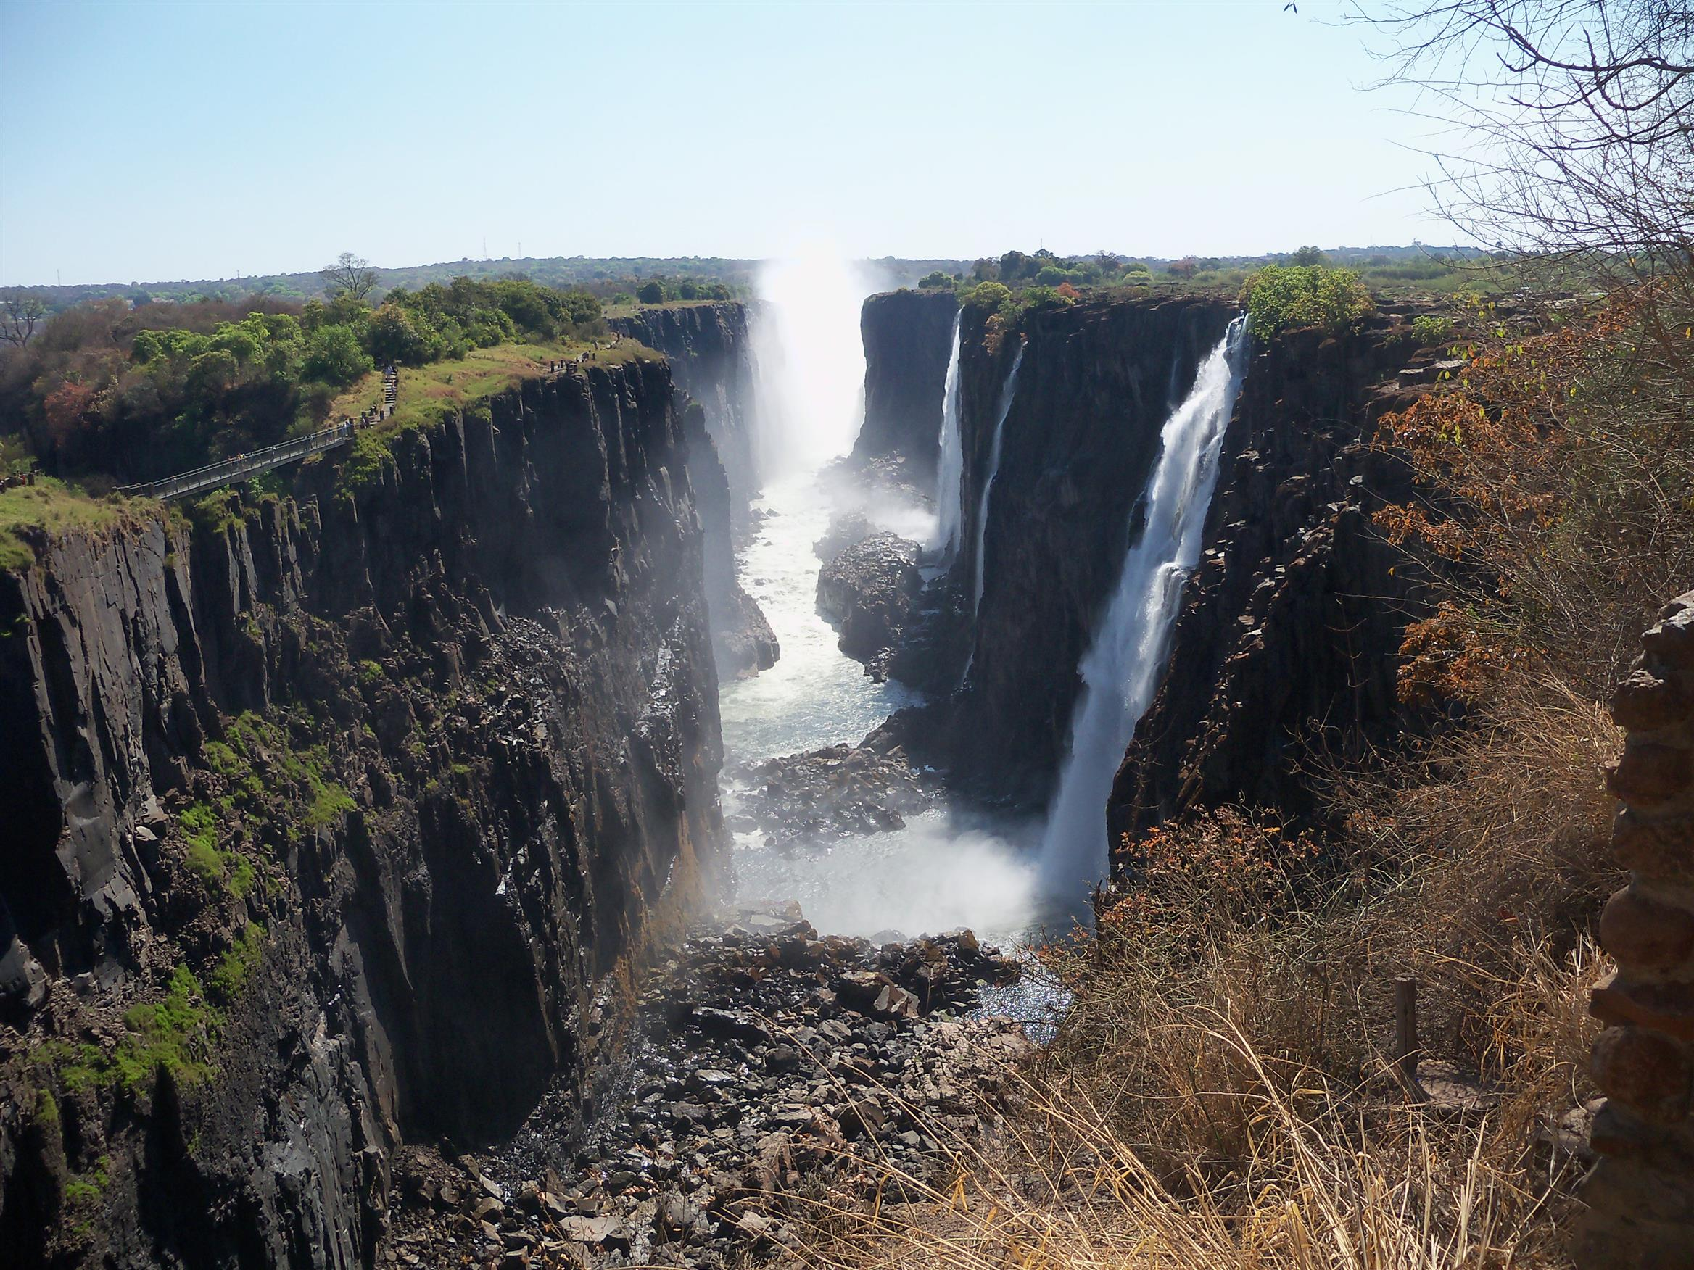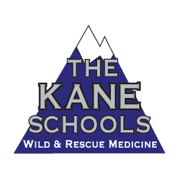

Dartmouth-EMS Presents

**Into Africa**

**Teaching and Working In Zambia**

An amazing place, the continent of Africa is the second most populated continent on Earth. It is home to 54 countries, 9 territories and diverse in many ways. This presentation covers three weeks teaching “village medicine” to prospective teachers and Tongan villagers. In between “work” there were trips to Botswana and Chobe National Park, Victoria Falls, healthcare work in Nsongwe, and an opportunity to see the work of Overland Missions, who are drilling wells all over Africa. 90 Minutes.

**Date: September 26, 2017, 6:30 pm**

**Location:**

**Free Admission**

Bill Kane…**thekaneschools@gmail.com** 