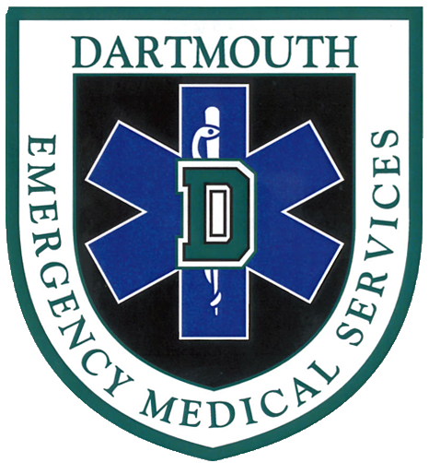
Dartmouth EMS
Fall 2016 Programming
(Scenario Sessions, Meetings, and Special Events)

1. Scenario Session: Protocol Specific Review
Thursday, September 15th
7-9pm; Rocky 001

2. Lecture: “Anatomy of a Mountain Rescue” with Bill Kane – Open to the public
Tuesday, September 20th
7-8:30pm; Haldeman 041

3. Scenario Session: Outdoor Emergencies – Open to non-DEMS Dartmouth Students
Friday, September 23rd
5-7pm; BEMA

4. Scenario Session: Equipment Training – Open to non-DEMS Dartmouth Students
Wednesday, September 28th
6-8pm; Kemeny 006

5. Captain’s Practice: TBD
10/3-10/10
TBD

6. Scenario Session: Turn up the Heat! (High Pressure Situations)
Monday, October 10th
6:30-8:30pm; Alpha Chi

7. Scenario Session: Respiratory Emergencies with Manikins
Wednesday, October 19th
7-9pm, Kemeny 006

8. MANDATORY Scenario Session: Homecoming
Monday, October 24th
7-9pm, Kemeny 007
Mandatory for anyone taking a Homecoming Shift

9. Case Review with Dr. Tom Trimarco
Tuesday, November 1st
8:30-9:30pm, TBD

10. Thinking Outside The Box with Chris Rousseau– Open to non-DEMS Dartmouth Students
11/7-11/11 (TBD)
TBD

