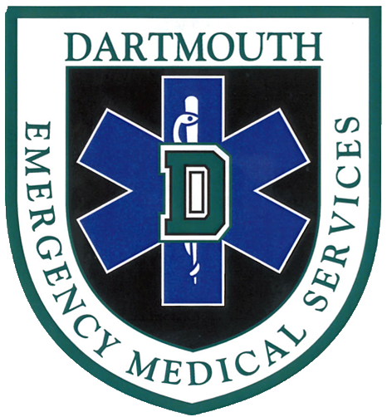
Dartmouth EMS
Spring 2016 Programming
(Scenario Sessions, Meetings, and Special Events)

Part II: Weeks 6-10

9. Meeting: Review of Protocols
Monday, May 2nd
7-8pm; Carpenter 013

10. Scenario Session: Musculoskeletal Care
Thursday, May 5th
6-8pm; Kemeny 108

11. Captain’s Practice: Wilderness Medicine
Wednesday, May 11th
5-6:30pm; Green
Hosted by Sam Kocen ‘19

12. Special Event: Patient Panel
Thursday, May 12th
7-8:30pm; Silsby 312
Springing into action

13. Scenario Session: Green Key
Monday, May 16th
6-8pm; Carson L02
Mandatory if taking a shift over Green Key

14. Meeting: Water Emergencies Lecture
Monday, May 23rd
7-8:30pm; Rocky 002
Presentation by Captain Thibeault from the Hanover Fire Department

