CASCADES - Launch

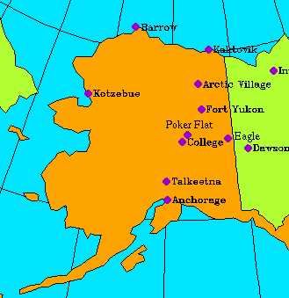
Where: The Rocket will be launched from Poker Flat Research Range in Alaska in early March 2005. Poker Flat is 30 miles north of Fairbanks Alaska and is the world's only scientific rocket launching facility owned by a university.
When: The rocket will be launched in late February or early March. There are a number of different reasons why the rocket must be launched from this place at this time.
Because this launch is studying a specific aspect that is related to the aurorae (Northern lights) it will be launched when the auroras are active. The aurora can be seen most often in Northern latitudes, so this is why the researchers travel to Alaska. They must travel in the winter, because in the summer Alaska has almost 24 hours of daylight which means that the aurorae would not be visible. Furthermore, the rocket will not be launched when there is a full moon, because at this point the auroras also cannot be seen.
Below is a picture of the Northern lights taken by Jan Curtis. For more images from the same photographer, see http://www .geo.mtu.edu/weather/aurora/images/aurora/jan.curtis/images/
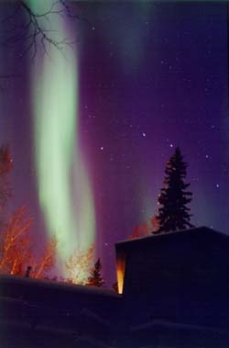
Conditions: For the launch to be successful there are other conditions that must be fulfilled.
- It must be a clear night at both Poker Flat as well as Kaktonic.
- The wind must be steady. It is fine if there is a wind because they can make calculations and changes to adjust for it, but if the wind is constantly switching directions no adjustments can be made and the rocket can't be launched.
- Furthermore there can be no air traffic; at this place and time air traffic generally consists of helicopters and medivacs.
- Finally, the aurora must be a good event and have a clear morphology. This means that the data collected from satellites and observations of the aurora in Russia must show that the aurora will last and not be incredibly irregular.
Once it is launched there are ideal conditions that the rocket can reach as well as minimal conditions for it to be considered a successful experiment. For more detail on this, see the schedule page.

